Assignment (12/03/2026)

Assignment Name :Decision Tree on Paper – Should I Play Outside?

Objective
The objective of this assignment is to understand how a Decision Tree algorithm makes decisions by splitting data based on conditions. We will create a simple decision tree to predict whether we should play outside or not based on weather conditions.

Features Considered
To make the decision, we consider the following factors:
- Weather (Sunny / Rainy / Cloudy)
- Temperature (Hot / Mild / Cool)
- Humidity (High / Normal)
- Wind (Strong / Weak)
Decision Tree Structure

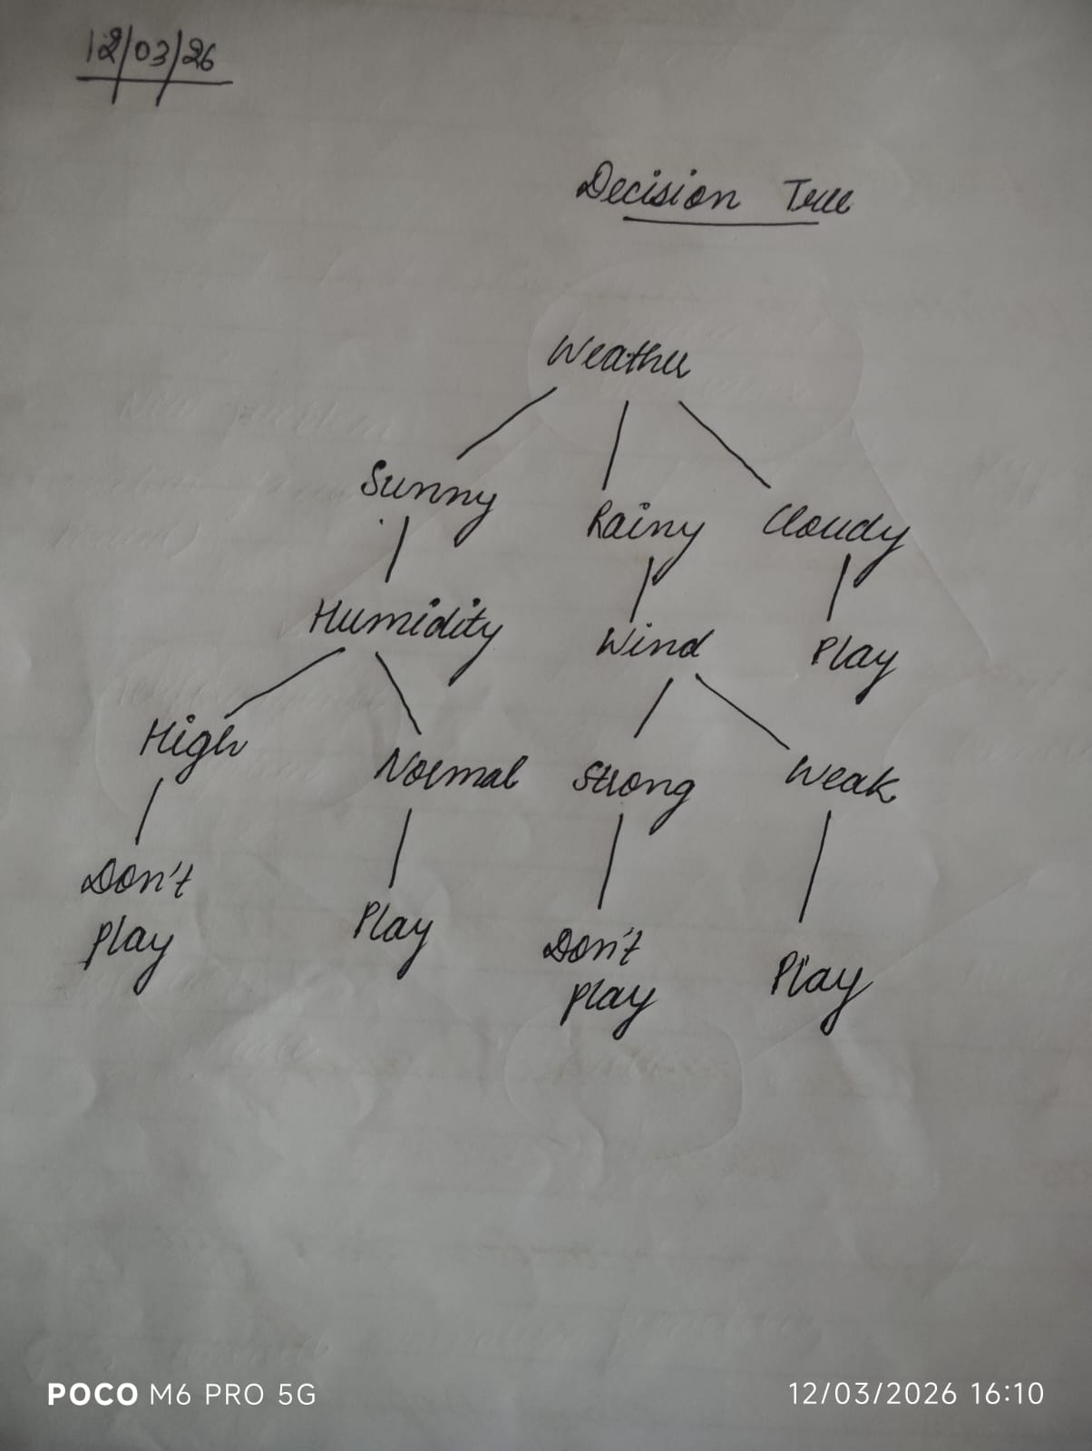

Explanation
- If the weather is Sunny
  - If humidity is high → Don't Play
  - If humidity is normal → Play
- If the weather is Rainy
  - If wind is strong → Don't Play
  - If wind is weak → Play
- If the weather is Cloudy
  - Play outside

Conclusion
A Decision Tree helps make decisions step by step using conditions. Each internal node represents a feature, branches represent rules, and leaf nodes represent the final decision. This method is easy to understand and widely used in classification problems in machine learning.

